Guided Capstone Project Recap

By

Brian Wilson

We were given the task of reviewing data on 330 resorts including our own, Big Mountain. The goal was to determine if a change in our pricing was reasonable based on comparison to our peers. After some extensive exploration of the data and the creation of a model we conclude that an increase in price is reasonable.

Our recommendation is based upon the exploration of the given data and the creation of a predictive model using a random forest regressor to determine the best variables to use in determining the weekend ticket price. As can be seen in the right graph below, the top variables are number of fast Quad lifts, number of runs, acreage with snow making capability and total vertical drop for the mountain. This is consistent with what was found using a principle component analysis to determine which variables were correlated to ticket price.

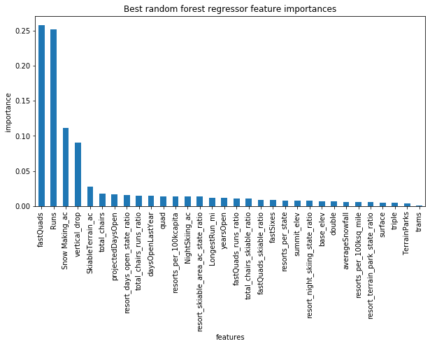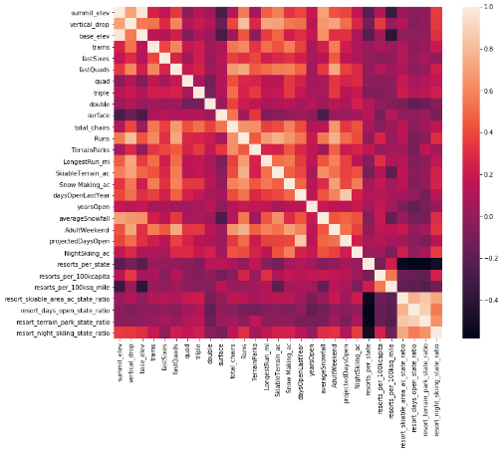

The model predicted a resort with our attributes (variables) would charge a ticket price of $94.22, a $13.22 increase over the current ticket price of $81.00. The predicted price has an error of up to $10.39, which still allows for a $2.83 increase in ticket price. Further research into the clientele at the resorts used in the model could allow for a model with increased accuracy, by eliminating any resorts that have dissimilar client bases. The scenarios that we were asked to review breakdown as shown on the following page:

1. Scenario 1
   1. Details: Permanently closing down up to 10 of the least used runs. This doesn't impact any other resort statistics.
   2. 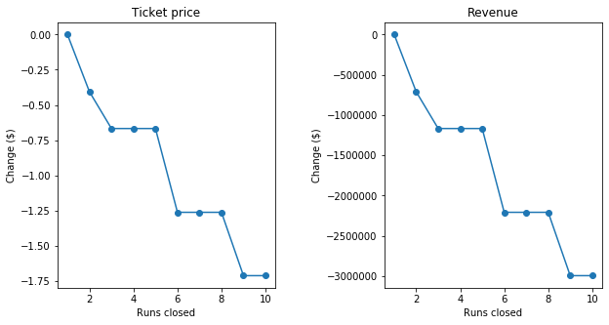Predicted Outcome: Closure of 1-3 runs creates increasing revenue lose based on lower ticket prices. The loss plateaus between 3 and 5 and we would not recommend closing more than 5 runs.
2. Scenario 2
   1. Details: Increase the vertical drop by adding a run to a point 150 feet lower down but requiring the installation of an additional chair lift to bring skiers back up, without additional snow making coverage
   2. Predicted Outcome: Ticket prices could be increased by $1.99 which would increase revenue $3,474,638 based upon the provided visitor count data.
3. Scenario 3
   1. Details: Increase the vertical drop by adding a run to a point 150 feet lower down but requiring the installation of an additional chair lift to bring skiers back up, adding 2 acres of snow making cover
   2. Predicted Outcome: These changes would have no effect on the predicted ticket price, which means no change to revenue.
4. Scenario 4
   1. Details: Increase the longest run by 0.2 mile to boast 3.5 miles length, requiring an additional snow making coverage of 4 acres
   2. Predicted Outcome: These changes would have no effect on the predicted ticket price, which means no change to revenue.

Based on the predicted outcomes above and assuming the respective change in costs are covered by the change in revenue we recommend moving forward with scenarios 1 (up to 5 runs) and 2.